Final Proposal – Small Modular Reactor
Technical Writing for Engineers
City College - English Department
Gregory Kim

5-7-19

Summary
The project that is being proposed is a small-modular reactor (SMR) that will be constructed to supply energy to developing countries that need power. Not only will it provide energy, it will help reduce the emission of carbon and greenhouse gases. The engineer who is proposing this project is Gregory Kim. He is currently a student at CUNY City College in New York. He has an interest in learning about clean, renewable energy technology that will help reduce the effects of global warming. He hopes to graduate in 2020 with a bachelor’s degree in mechanical engineering. The proposed budget for this project is $2.5 billion dollars.

Table of Contents
Introduction 3
Proposed Program 6
Innovation Process 8
General Cost Estimation 9
Conclusion 12
Appendices 12
References 13

Introduction

These are the articles that will be referenced throughout in the final proposal. The first article is “Economic viability of light water small modular nuclear reactors” written by Black, G. A., Aydogan, F., & Koerner, C. L. It was published by Renewable & Sustainable Energy Reviews in 2019. This article discusses about whether small modular reactor is a viable solution in terms of economics by comparing its costs to existing nuclear power plants. While this article discusses the economic viability of small modular reactor, the next article discusses about how much energy is consumed in developing countries. It is titled “Energy consumption levels and technical approaches for supporting development of alternative energy technologies for rural sectors of developing countries.” written by Muhumuza, R., Zacharopoulos, A., Mondol, J. D., Smyth, M., & Pugsley, A. It was published by Renewable & Sustainable Energy Reviews in 2018. While the last article discusses about how much power is consumed in developing countries, the next article discusses how various renewable energy sources are used by developing countries. It is titled “Productive use of energy – Pathway to development? Reviewing the outcomes and impacts of small-scale energy projects in the global south.” written by Terrapon-Pfaff, J., Gröne, M.-C., Dienst, C., & Ortiz, W. It was published by Renewable & Sustainable Energy Reviews in 2018.
In Productive use of energy, it states that it is widely accepted that access to sustainable and affordable energy is important in reducing poverty (Terrapon-Pfaff et al., 2018, p. 198). According to Energy consumption levels, there are about 1.1 billion people in the world who do not have access to electricity (Muhumuza et al., 2018, p. 90). About 2.6 billion people use biomass, which brings air pollution (Muhumuza et al., 2018, p. 90). Biomass is organic matter such as plants that can be used for fuel. The Productive use of energy article writes about how various renewable energy technologies were used in twenty different developing countries, which are mostly in regions such as Sub-Sahara, Latin America, and Asia (Terrapon-Pfaff et al., 2018, p. 202). Afghanistan, Paraguay, and Tanzania are some examples of these countries (Terrapon-Pfaff et al., 2018, p. 202).
The technologies used in these developing countries include solar, wind, hydro, and biomass power to meet needs such as food preparation, lighting, electricity, and irrigation (Terrapon-Pfaff et al., 2018, p. 202). In terms of energy usage, solar power technology represented the largest at 45%. The second largest is biomass at 32%. Hydropower accounted for 13%. Terrapon-Pfaff et al. claim “that access to clean, affordable, and reliable energy services provided by renewable energy technologies will contribute to social and economic development. This development may take the form of employment, income and/or the strengthening of the local economy, as well as improving welfare – for example by reducing hardship and increasing time availability” (Terrapon-Pfaff et al., 2018, p. 202). Thus, energy production is vital to a nation’s economy such that it will reduce poverty. It is important that investments in energy continue in developing countries around the world.
However, one energy source that is not mentioned in the Productive use of energy article is nuclear energy. Due to the demand for energy consumption along with the need to reduce carbon and greenhouse gas emissions, investments in new carbon-free energy technology have become very important in today’s age (Black et al., 2018, p. 248). Thus, the small modular reactor (SMR) is an attractive technology, because of its small size, modular design, and better safety compared to existing nuclear technology. Even more, as the demand for energy increases and climate change becomes worse, the need for developing non-fossil energy has become imperative. Additionally, the use of SMR can be used anywhere, especially in developing nations, “many of which are experiencing what the United Nations has termed ‘energy poverty’ – the inability to obtain cost-effective energy production. SMR has the potential to help both emerging and industrialized economies to continue economic development while reducing the impact on global climate change” (Black et al., 2018, p. 248). Thus, SMRs are a viable solution based on its safety, relative low cost, and pollution-free technology (Black et al., 2018, p. 249). It will also solve the problem of energy poverty in these developing countries.
Black et al. notes that nuclear power has a history with problems of negative public perceptions of safety, financial losses, and project cancellations (Black et al., 2018, p. 249). Black et al. reference Tsoulfanidis who explains that “small modular nuclear reactors provide an alternative to large reactors and provide many of the benefits of clean energy production without many of the construction, planning, and safety concerns of their large nuclear counterparts” (Black et al., 2018, p. 249). In Economic viability of light water, it is clearly stated that the small modular reactor is a better choice than regular nuclear power, because of its safety as well as less overhead construction cost to build the plant. That is why small modular reactor should be considered to help developing countries that have energy poverty.
The background of the problem is that Professor von Uhl of the English Department at CUNY City College provided an article to the class that showed the new technologies that were currently available. After doing some research, I thought the technology of the small modular reactor developed by NuScale had the most practicality in terms of reducing greenhouse gases as well as providing energy to many who need it. In my research, I found that many developing countries needed an infrastructure for energy production that could meet their demands. Thus, I have decided that my final proposal should focus on explaining why these countries should invest in nuclear energy, particularly the small modular reactor technology.
What I hope to accomplish in this final proposal is to inform my audience that a small modular reactor is a viable option in providing energy to countries that need it based on its safety, relative low cost, and pollution-free technology. However, since the technology is relatively new, it is expected that it will take some time for the idea to be implemented. Not only that, it is still expensive to build and run the power facility, but its cost is significantly less than that of a nuclear power facility that is currently in use.

Proposed Program

Figure 1 shows a NuScale SMR, which is a light-water design that includes a reactor vessel, steam generators, pressurizer, and containment vessel (Black et al., 2018, p. 253). The SMR does not have coolant pumps and large core piping, which effectively reduces the risk of coolant accidents (Black et al., 2018, p. 253). Instead, it relies on natural processes such as gravity, conduction, and convection to cool the device (NuScale Inc, n.d.). The reactor is 65 feet tall and 9 feet in diameter. The containment vessel holds the reactor and its dimensions are 76 feet tall and 15 feet in diameter (NuScale Inc, n.d.). The reactor and containment vessels operate in a water pool, where no pumps are needed to circulate the water. The reactor uses buoyancy where the heated water rises. As the hot water in the reactor passes over hundreds of tubes in the steam generator, heat is transferred through the tube walls. The water inside the tubes turns to superheated steam. The steam goes through a turbine that is used to generate electricity. After going through the turbines, the steam loses its heat and is cooled back into liquid in the condenser. It is fed back to the steam generator where the cycle is repeated (NuScale Inc, n.d.).
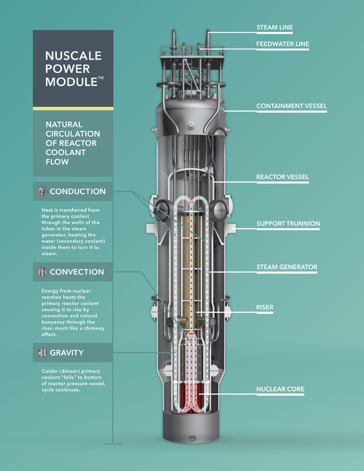
Figure 1: NuScale Power Module.
Wikipedia (2019, March 17).

The NuScale model has enhanced safety features by reducing many possible risks by taking out vulnerable pipes, pumps, and valves from the design (NuScale Inc, n.d.). It also increases safety by replacing many backup systems with features that rely on natural phenomena such as gravity, convection, and conduction. The small size of the reactor and the passive heat removal machinery assures that no fuel will be damaged after a catastrophic event. Thus, no radioactivity will be released. The model is also designed with additional safeguards that slows down the release of radiation in the extreme case that fuel is severely damaged (NuScale Inc, n.d.). Table 1 shows the specification of the NuScale Power Module.

Thermal Capacity | 200MWt
Electrical Capacity | 60MWe
Capacity factor | >95%
Weight | 700 tons

Table 1: Specification of a NuScale Power Module
(NuScale Inc, n.d.).

Innovation Process

Since the small modular reactor plant has many components as shown in Figure 2, this final proposal will mainly focus on the cost of building it. The economic viability of the SMR will be assessed by comparing its cost to existing energy production plants such as nuclear power. The detailed cost estimates for a Pressurized Water Reactor-12 (PWR-12) Nuclear Power Plant, provided by the Oak Ridge National Laboratory, will be used to estimate both direct and indirect capital costs (Black et al., 2018, p. 252). Later, the cost-estimation methodology used will be adapted to the design of the NuScale SMR, which is the only SMR currently being designed in the United States. NuScale was chosen, because its SMR design is most likely to be deployed within the next several years (Black et al., 2018, p. 257). It is the only commercial SMR design whose certification application is being reviewed by the Nuclear Regulatory Commission (Black et al., 2018, p. 257).
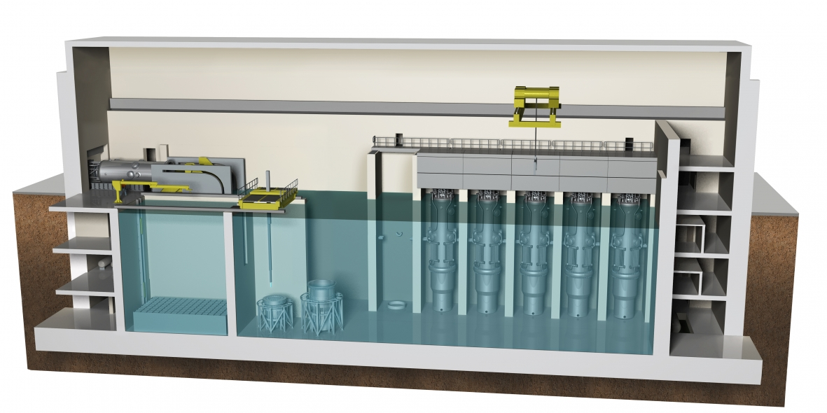
Figure 2: NuScale Power Reactor Building
Office of Nuclear Energy. (n.d.).

General Cost Estimation

The PWR-12 by Westinghouse, made around the 1970s, is a “four-loop pressurized-water reactor (PWR) with a core thermal power of 3417 MW, nuclear steam supply power of 3417 MW and net electrical power of 1147 MW. Light water is used for both cooling and as a moderator. Pressurizer, steam generator, coolant circulation pump, pressurized reactor vessel and control rods installed at the top of the reactor vessel are some of the components in the containment” (Black et al., 2018, p. 252). Figure 3 shows the containment vessel of the PWR-12. In addition, the reactor is powered by 193 fuel assemblies including UO₂ nuclear fuel. The reactor is designed for a 30-year life (Black et al., 2018, p. 252). Table 2 shows the cost analysis of the PWR-12 and the NuScale Power Module. The data for the PWR-12 was then adjusted for the manufacture and construction of a typical SMR design (Black et al., 2018, p. 257).

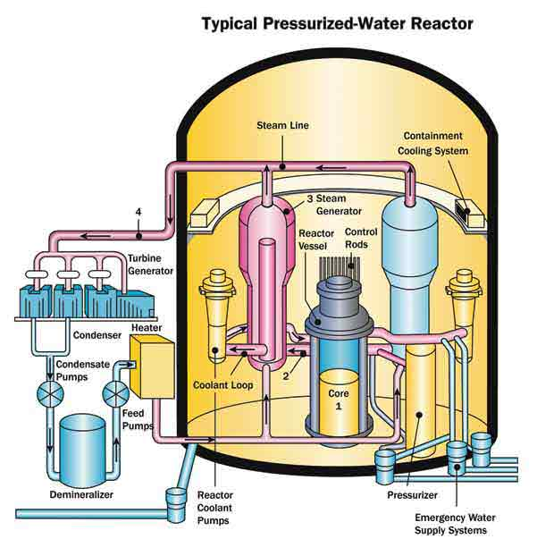
Figure 3: Typical Water Pressurized Reactor.
Visual Encyclopedia of Chemical Engineering (n.d.).

COA | General Description | NuScale SMR Cost | PWR-12 Cost | Cost Difference
20 | Capitalized Direct Costs | $1,805,616,142 | $3,033,426,240 | $1,227,810,098
21 | Structures and Improvements | $612,136,797 | $1,188,461,160 | $576,324,363
22 | Reactor Plant Equipment | $869,360,876 | $659,196,360 | -$210,164,516
23 | Turbine Plant Equipment | $196,121,808 | $561,670,200 | $365,548,392
24 | Electric Plant Equipment | $34,982,052 | $309,061,440 | $274,079,388
25 | Heat Rejection Systems | $62,934,255 | $131,896,080 | $68,961,825
26 | Miscellaneous Plant Equipment | $30,080,354 | $183,141,000 | $153,060,646
30 | Capitalized Indirect Costs | $663,710,610 | $3,375,000,000 | $2,711,289,390
31 | Design Services at Home Office | $130,978,572 | $1,204,741,080 | $1,073,762,508
34 | Field Construction Management | $60,906,859 | $82,438,560 | $21,531,701
35 | Field Construction Supervision | $246,930,385 | $970,896,240 | $723,965,855
36 | Field Indirect Costs | $224,894,794 | $1,116,924,120 | $892,029,326
 | Base Construction Cost | $2,469,326,752 | $6,408,426,240 | $3,939,099,488

Table 2: Cost Comparison for NuScale SMR and PWR-12.
Black, G. A., Aydogan, F., & Koerner, C. L. (2019).
As shown in Table 2, the NuScale model is much less expensive than the PWR-12 design in total base construction costs as well as both capitalized direct and indirect costs (Black et al., 2018, p. 256). Total base construction is $3.94 billion less than PWR-12. Capitalized direct cost is $1.23 billion less. Capitalized indirect cost is $2.7 billion less (Black et al., 2018, p. 256). From the results, it is clear that NuScale SMR is less expensive than PWR-12 NPP in terms of cost and investment. The time to construct a fully functional SMR plant should take about 3 years to complete (NuScale Inc, n.d.). The workforce to build it is around hundreds of people, not thousands (NuScale Inc, n.d.).

Conclusion

In conclusion, the small modular reactor (SMR) is a viable technology that will provide energy to developing nations that need it. Because of its small size and modularity, it can be easily maintained and built. Not only supplying a lot of energy, the small modular reactor also reduces carbon and greenhouse gas emissions such that it will help reduce climate change. It is friendly to the environment as well as providing the necessary energy to the people who need it. Even though it is expensive to build, its cost is significantly less than the current nuclear plants that are out there. In addition, SMR is much safer, because it has less of a chance in having an accident by removing unnecessary pipes and pumps. It relies on gravity, convention, and conduction in its mechanism for the device to operate.

Appendices

Schedule of Tasks
4/8-4/21 | Research, Proposal Drafting
4/22-4/29 | Proposal Drafting, PowerPoint Drafting
4/29-5/3 | Peer Review at Writing Center
5/4-5/6 | Proposal Revision, PowerPoint Revision
5/7 | Final Proposal Submitted
5/9 | Presentation Given

References

Black, G. A., Aydogan, F., & Koerner, C. L. (2019). Economic viability of light water small modular
nuclear reactors: General methodology and vendor data. Renewable & Sustainable Energy
Reviews, 103, 248–258.
https://doi-org.ccnyproxy1.libr.ccny.cuny.edu/10.1016/j.rser.2018.12.041
Muhumuza, R., Zacharopoulos, A., Mondol, J. D., Smyth, M., & Pugsley, A. (2018). Energy
consumption levels and technical approaches for supporting development of alternative energy
technologies for rural sectors of developing countries. Renewable & Sustainable Energy
Reviews, 97, 90–102. https://doi.org/10.1016/j.rser.2018.08.021
NuScale Inc. (n.d.). Technology Overview. Retrieved from
https://www.nuscalepower.com/technology/technology-overview
Office of Nuclear Energy. (n.d.). Advanced Small Modular Reactors (SMRs). Retrieved from
https://www.energy.gov/ne/nuclear-reactor-technologies/small-modular-nuclear reactors
Terrapon-Pfaff, J., Gröne, M.-C., Dienst, C., & Ortiz, W. (2018). Productive use of energy – Pathway to
development? Reviewing the outcomes and impacts of small-scale energy projects in the global
south. Renewable & Sustainable Energy Reviews, 96, 198–209. https://doi.org/10.1016/j.rser.2018.07.016
Visual Encyclopedia of Chemical Engineering (n.d.). Nuclear Reactors. Retrieved from
http://encyclopedia.che.engin.umich.edu/Pages/Reactors/NuclearReactors/NuclearReactors.html
Wikipedia (2019, March 17). NuScale Power. Retrieved from
https://en.wikipedia.org/wiki/NuScale_Power

